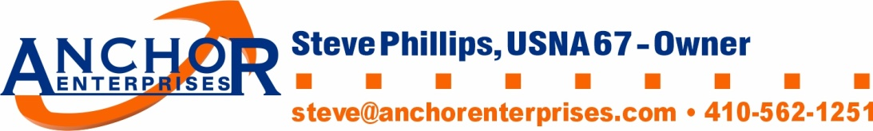
Anchor Enterprises
Refund/Return & Exchange Policy
Refund or exchange for any apparel items received can be requested.
Refunds or exchanges for non-apparel items (mugs. tumblers, ball hats, etc.) are not available
All refund or exchange requests must be done via email (usna@anchorenterprises.com).
Anchor Enterprises must be notified of the request for return/exchange or refund within 10 days of receipt of the item. Returned/exchanged items must be returned within 10 days of notification.
The request must indicate whether the customer wants a refund or exchange. For exchanges, provide all item details such as color, size, Item Number, etc.
Return the item in new condition to:
Anchor Enterprises
8606 Wintergreen Court #106
Odenton, MD 21113

Include Ship To Address for exchanges. Include all item details such as color, size, Item Number, etc. for the replacement item requested.
If the item in question was damaged or not the item ordered, Anchor Enterprises will pay for the shipping cost of the returned and replacement items. If the item is being returned for a size or color change, the customer must pay for the return and replacement shipping costs. If the item is being returned for a size or color change, the customer must pay a restocking fee of $15.00 per item. If an exchange is for a size larger than XLarge, the size upcharge cost listed on the web site must also be paid by the customer.

